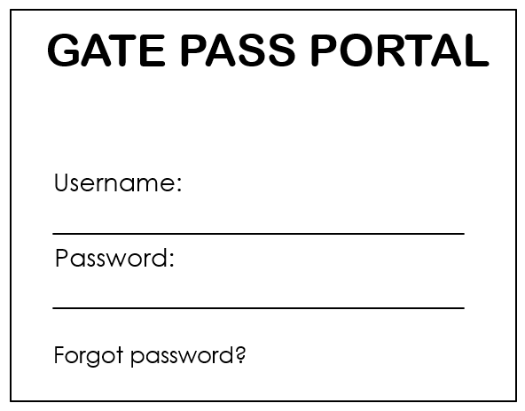

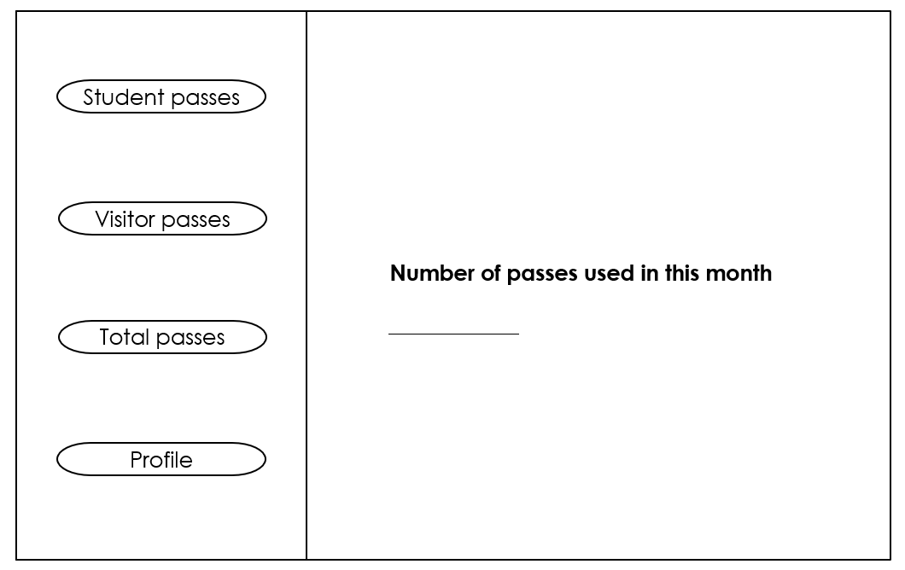

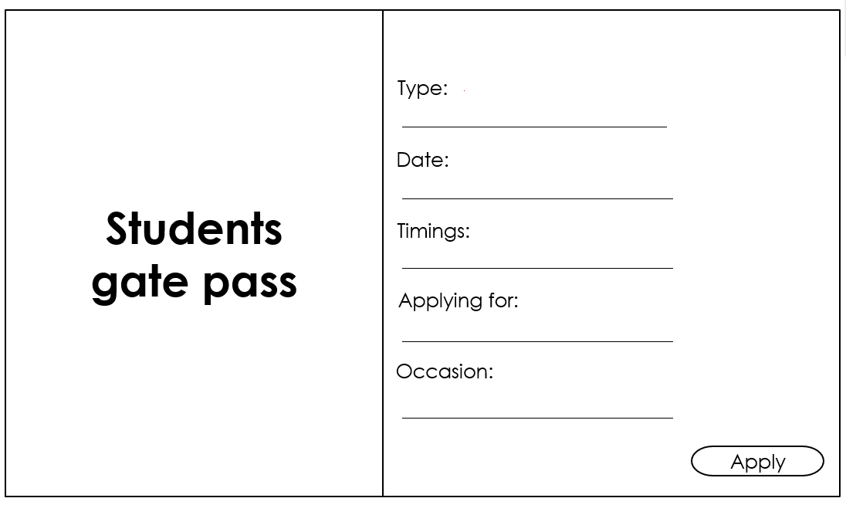

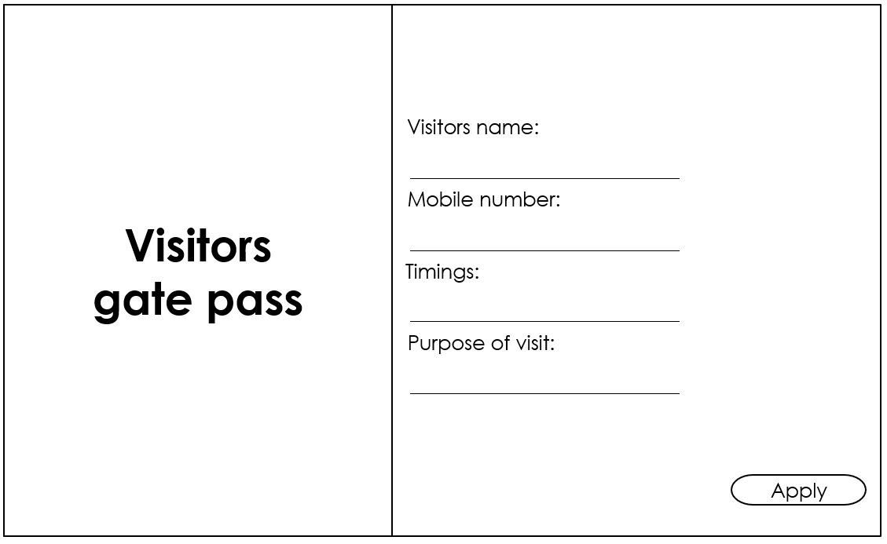

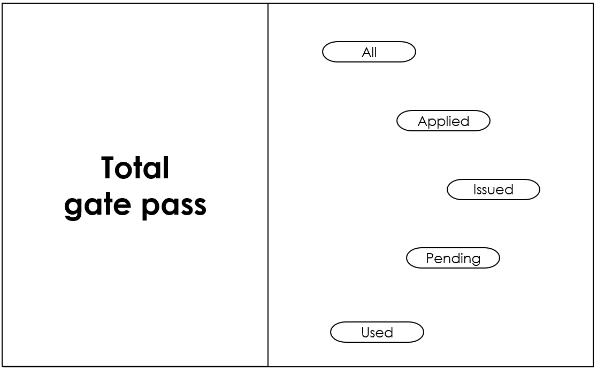

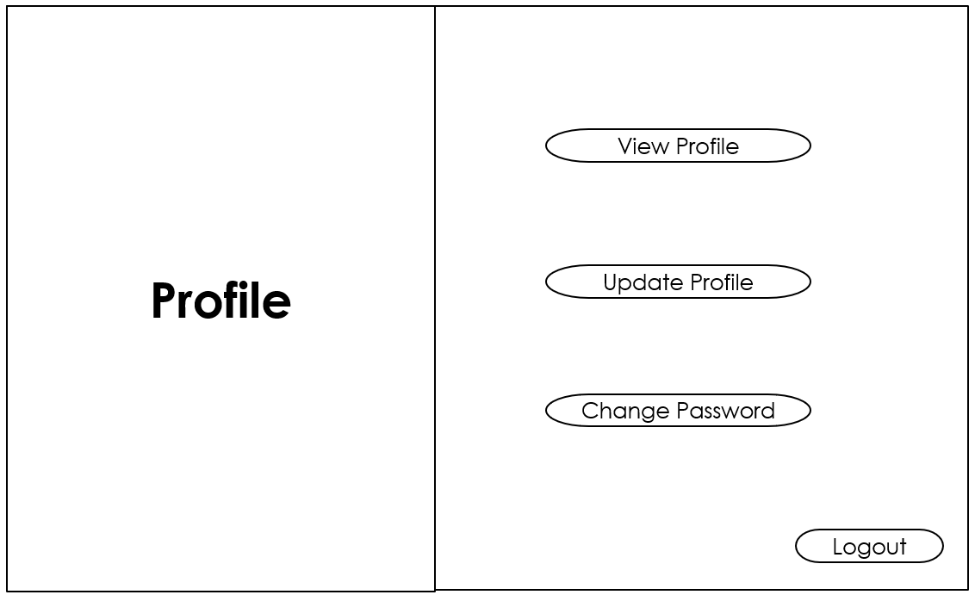

**User Analysis:**

Step 1: The portal to login for applying gate passes.

Step 2: There will be the list of types and types of passes and also it shows how many passes used in the current month.

Step 3: when the student/visitor click on the particular pass type, particular form will be opened.

Step 4: Then student/visitor should apply for either day pass or home pass according to their preferences and he/she should apply preferred pass for warden or advisor accordingly. If that particular person is applying home pass or day pass during weekend or holiday, she/he should apply for warden. Where as if that particular person is applying during week days, he/she should apply for class advisor.

Step 5: He/she can fill the following form and can apply the pass.

Step 6: After they applied, they can see the status of the pass whether it is in pending/issued. If we use the pass, we can see how many passes used in the used option.

Step 7: If we want to make any changes in the profile like update/edit or to change password user can do it or else user can logout from the portal.